**Databases Laboratory Work Nr.3**

**Title:** *CREAREA SI MODIFICAREA TABELELOR IN SQL SERVER MANAGEMENT STUDIO*

**Prerequisites:** SQL Server Management Studio

**Objectives:**

Table creation, columns definition and default properties setup, advanced column properties, primary key setting and overall table modifying.

**Tasks:**

**1)** Care din numerele prezentate mai jos pot fi introduse intr-un camp de tipul DECIMAL(4, 1)?

a) 16,2; b) 116,2; c) 16,21; d) 1116,2; e) 1116,21.

**2)** Fie [Coll] din tabelul de mai jos este de tip INT, si [Col2] este de tip DECIMAL (2,1).

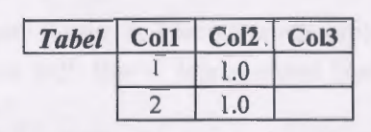

Ce tip de date trebuie sa fie [Col3] pentru a pastra rezultatul urmatoarei expresii: Coll1*Col2.?

**3)** Creati o baza de date numita universitatea cu proprietati implicite. In cadrul acestei baze de date, creati 2 tabele (grupe, discipline), schemele carora sunt definite in sectiunea 3.3 a capitolului.

**4)** Inserati in tabelele respective ale bazei de date universitatea urmatoarele inregistrari:

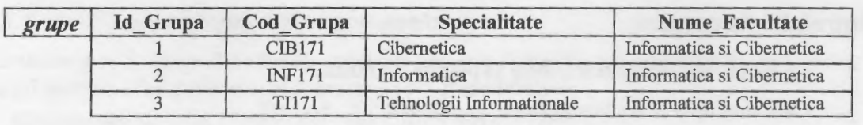

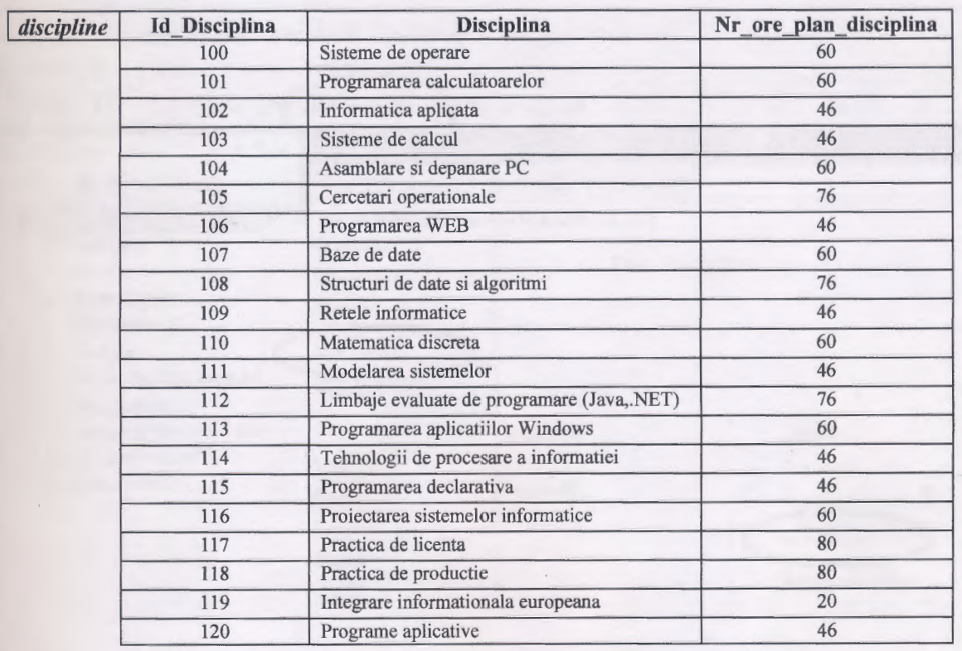

**Implementation:**

**1)** a, b, d

**2)** DECIMAL(2, 1), in case the multiplication may lead to a number length change, dec(3,1) would be more rational

**3)** 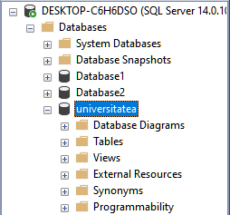

University database has been created   
&  
Tables properties are shown below



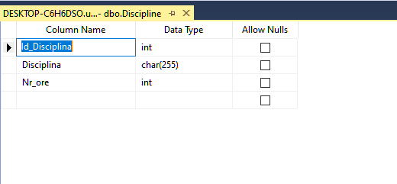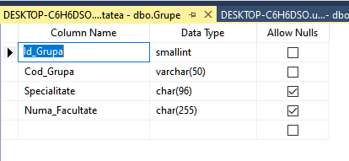

**4)**

Showcase of tables content

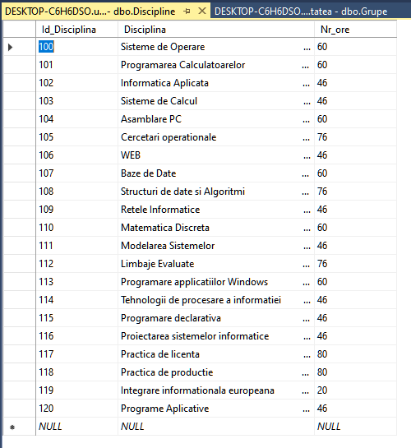

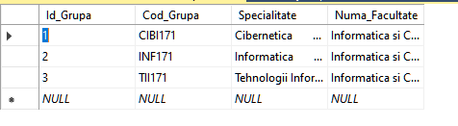

**Conclusion:**

In this laboratory work we’ve learned to create tables in our database, configure them, design them, add restrictions and fill them with content. Also we’ve learned about data types and operations with columns such as multiplication of two columns with different data types

Britchi Daniel FAF-191